**Yarmouk University**



**Information Technology and Computer Science**

**Information Systems (IS)**



**MAZ House Selling & Renting**

Zakarea Farooq Bani Hani, 2019902001

Mohammad Hani Bani Abed AL-Ghani, 2019902182

Ayman Amjad Saifan, 2018902159

Supervisor

Dr. Aws Magableh

**Acknowledgement**

**In the name of god, the most gracious the most merciful and prophet Mohammad peace upon him. First of all, we’d like to thank our supervisor Dr. Aws Maqableh for all the assistance he offered us. Furthermore, we thank the course supervisors in general Dr. Iyad Al-Azzam Dr. Emad Shawaqfeh, Dr. Mariam Nusair.**

**Table of Content**

|  |  |
| --- | --- |
| **Content** | **Page Number** |
| Introduction | 5 |
| Project Overview and Analysis | 6 |
| Literature overview | 7 |
| Requirement Phase(functional and non-functional requirements) | 7-9 |
| Analysis Phase | 10-19 |
| Design Phase | 20-22 |
| References | 23 |

**Table of Figures**

|  |  |
| --- | --- |
| **Figure Type** | **Page Number** |
| Use Case Diagram | 10 |
| Use Case Specification | 11-16 |
| Activity Diagram for the entire system | 17 |
| Activity Diagram for two complicated behaviors | 18-19 |
| Context Diagram | 20 |
| ER-Diagram | 21 |
| Database Schema | 22 |

**Table of Use Case Specification**

|  |  |
| --- | --- |
| **Name of The use case** | **Page Number** |
| Table (1): Authorization | 11 |
| Table (2): Insert Houses | 11 |
| Table (3): Answer Customer Questions | 12 |
| Table (4): Sign In | 12 |
| Table (5): Create new account | 13 |
| Table (6): Enter his information | 13 |
| Table (7): Browse the website | 14 |
| Table (8): Purchasing houses | 14 |
| Table (9): Rent Houses | 15 |
| Table (10): Contact | 15 |
| Table (11): Offer his house price | 16 |

1. **Introduction**

Many people suffer while trying to find a house to buy or rent, or even while trying to sell/rent their houses. MAZ team is willing to end customers and owners suffering by offering their services. MAZ website is a website for house selling and renting. Offering a lot of new features, targeting customer satisfaction. The website allows you to search for houses listed for sale or rental. As well as being able to contact with an admin to list your house on sale. Furthermore, you will be able to contact an admin for any further inquiries and any complaints.

The house selling and rental system is searching based on the apartment house for sale or rental in metropolitan cities. The house rental system is based on the owners and the customers. This web application helps user to register individual home or apartment to assist you in finding the perfect purchase or house rental.

In addition, we can find your next purchase or rental from search view in your targeted area. This website is designed to achieve all customers and house owner needs from buying, selling or renting houses in Jordan.

Houses helps us to maintain the database of various property & customer information. It does not only help us to maintain the customer information but here we also allow customers to access the portal updated information and listed advertisements of houses across the global environment.

We know it is tiring to call individual houses of customer, arrange appointment, finding better time for appointment and they will assist you. For such complex process we provide a one simple online form which requires your basic information and we will assist in sort time period. This all goes through Chatbot to begin with. If Chatbot aren’t able to satisfy customer needs, the customer has an option to contact and admin directly.

1. **Project Overview and Objectives**

**2.1(Project Overview)**

All citizens need houses to live in. It’s one of each individual life basics. Therefore, we or our close ones as citizens have always suffered from such problems. So, we came up with this idea where all Jordanian’s even stake holders can participate in. MAZ website will offer customers a place to look for houses for sale or rental. To try to make it easier and accessible for everyone. For example, employees don’t have the time to go look for houses on field. This is where our website comes in handy in such case.

Home ownership means the buyer has purchased a housing unit as property. Home ownership in our website made possible through cash payment. Furthermore, house owners will be able to contact admins to reach an agreement to list their houses for rental or sale. When an agreement is reached the admin validates it and posts an advertisement. On the other hand, customers can view our website and utilize all features freely.

**2.2 (Objectives)**

**1- Sell More Houses:**

If you're a real estate agent, your obvious goal is to increase sales. The challenge is figuring out how to set reasonable targets and motivate yourself. In his 2004 article "Sales Coach: Go for the Goals" for "Realtor Mag," writer John D. Mayfield suggests speaking with colleagues, assessing market conditions and considering the impact of personal events, such as the birth of a child, when setting personal sales targets. He also suggests giving your objective a timeline and operationalizing high-level goals. For example, if you want to get three more listings in the next month and you use a combination of cold calling and direct mailers to generate business, estimate the number of new clients you get from these marketing efforts to determine how much promotion you need to do to hit your target. The "Realtor Mag" article "5 Questions to Ask in Setting Sales Goals" suggests looking at your average number of closed transactions during the last two years to set aggressive, yet realistic goals.

**2- Customer Satisfaction:**

Connecting with our customers is the only real way to measure customer satisfaction. One of the most common methods of measuring customer satisfaction is through surveys. Which our website offers from time to time. Surveys that are answered by our customers are taken very seriously. In addition to surveys, customers can contact admins at any time to give any advice or note about any issue.

**3- Make profit:**

We as entrepreneurs think of ideas to first solve problems as well as making ourselves some profit. In this website our profit mainly comes from the percentage we take when listing houses on auction. The main real difference is that our percentage is lower than any other competitors.

**3.0 Literature review**

1. Zillow: The website is coded with Java programming language leveraging YUI JavaScript framework. It makes use of web analytics tools like comScore and Google Analytics and is hosted on an Apache Tomcat 4.1+ web server. The loading time of the website is 1.12 seconds.
2. Briggs Freeman: Developed using Drupal CMS by Root Info Solutions, a real estate website development company, the website enables users to connect with real estate customer or brokers in their localities to help them find their dream home. Taking a look at the high-resolution image of luxury homes and ranches do you doubt its performance? It loads in 2.26 seconds.
3. Trulia: The website is coded with PHP programming language. The monitoring of traffic and user experience is offered through web analytics tools like comScore Google Analytics and UASiteCatalyst. The website is hosted on Apache 2.4.18 web server. The website takes on an average 3.04 seconds to load.
4. **Requirement Phase**

**4.1 List of functional requirements**

**-Customer responsibilities:**

**How the website works:**

1-Customer signs in to the website using his login credentials (username & password).

2-Customer signs up if he doesn’t have an account.

3-System asks the user to create a new account if he doesn’t already have one.

4- System asks the user to enter his (first name, last name, email, password).

5- Customer can then browse to see all house options currently available on the main page where he can navigate from one page to another.

6-Customer can choose purchasing houses in cash or in installments or just browsing to see house prices with specific details (ex: house prices in a specific area).

**Website features for customers:**

1-Customer gets a list of houses for sale or houses available for rental which is displayed on the main page. Each house is displayed in pictures with a description including house details.

2-Customer gets to choose the house details when searching for a house.

3-Buying houses in installments (the house will not be assigned to the customer’s name till the final installment is paid, installments shall be paid in the time provided if he got a deal with the owner)

4-After a transaction is made, the system will give a notification to the user then the request has been send to the owner of the house.

**House Renting:**

Customer navigates to the rental page. Then he can browse the houses available and checks price estimates. If the customer finds the house he wants and if the house is available, the customer reaches out to the seller. With our website taking certain fees depending on the house and other complications. After a transaction is made, the system will give a notification to the user then the request has been send to the owner of the house.

**House details:**

1- House type.

2- House Address.

3- Rental value.

4- Road number.

5- House number.

6- Floor number.

7-Bedroom count.

8-Dining Room.

9-Kitchen.

10-Balconise.

11-BathRooms count.

12- picture of the house.

**Owner responsibilities:**

1-Authorize either accept or reject the customer Request.

2-Customers contact owner if they reach an agreement or make a deal.

3-Owner insert his house either for sale or rent, and insert his house details in the website.

4-Answer customer questions.

5- Owner can browse the website without buying or renting any house.

6- Owner can change his post or delete it from the website.

* 1. **List of non-functional requirements**

1. Response time within one day.
2. The quality of being able to provide good service.
3. Maintainable: the probability that a failed component or system will be restored or repaired to a specified condition within specified time.
4. Secure: certain to remain safe and unthreatened, keep all user and owner data safe.
5. Availability: the quality of being able to be used or obtained by the hour (on demand service).
6. Usability: The website should be effective (customer always finds what he’s searching for), efficient (system should always be up to date. In which, no errors are made) and satisfying (customer is always happy about the outcome of using the website).
7. Scalability: as our website grows in popularity system should be able to handle all customer connections without any loss of performance.

**5.0 Analysis Phase**

**5.1 Use Case Diagrams:**

A use case diagram is a graphical depiction of a user's possible interactions with a system. A use case diagram shows various use cases and different types of users the system has and will often be accompanied by other types of diagrams as well. The use cases are represented by either circles or ellipses. [1]

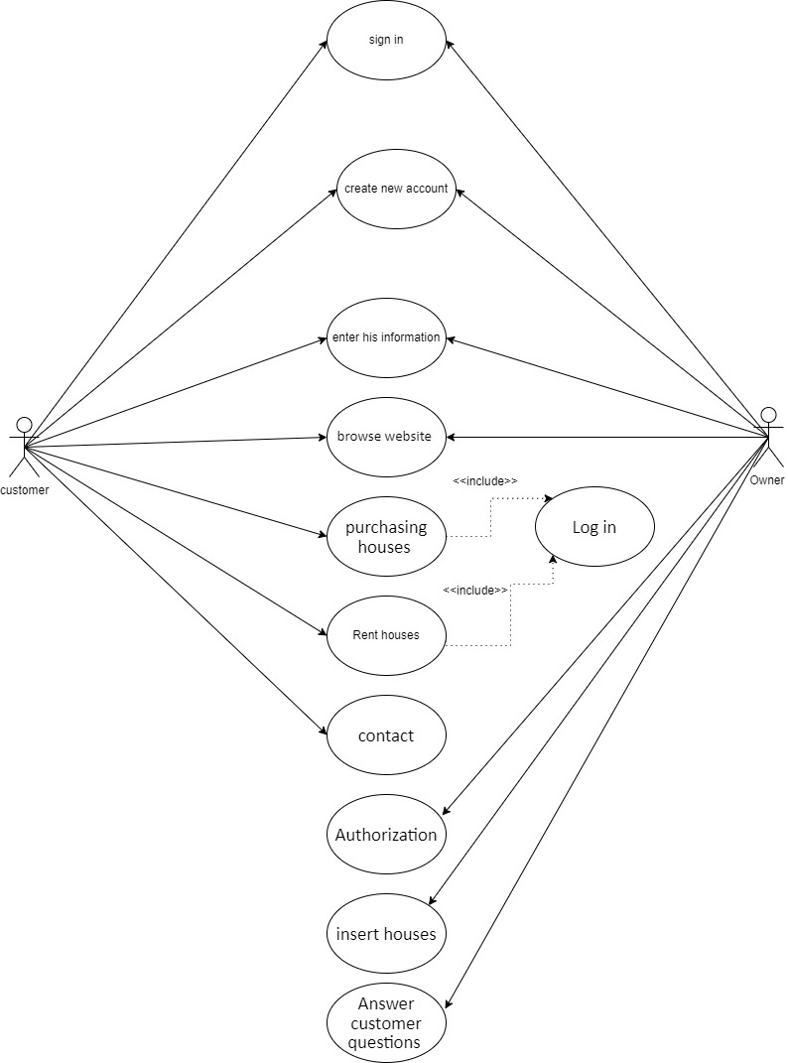

Figure (1): Use Case

In this figure is a use case that have three Actors and they are the customer, the owner, and it contains eleven use case each case is represented by one or more actor.

**5.2 Use Case Specifications:**

**Table (1):** **Authorization**

|  |  |
| --- | --- |
| Use Case Name: | Authorization |
| Actors: | Owner |
| Normal Course: | 1. House owner has an option to list houses for sale or rent 2. House owner is at least 18 years old. 3. Owner gets notified when a customer is interested in the listing. 4. Owner either agrees or rejects proposal. 5. Owner can then delete the advertisement. |
| Alternative Course: | 1. House seller is less than 18 years old. No further transactions can go ahead. 2. House owner can’t list house because he hasn’t filled all fields as required. 3. House owner doesn’t get notified about customers’ requests. |
| Pre-Condition: | Owner should be able to list as many houses as he wishes with the details he wishes to add. |
| Post-condition: | Houses are listed on available houses page and owner gets notified when a customer is interested. |

**Table (2):** **Insert Houses**

|  |  |
| --- | --- |
| Use Case Name: | Insert Houses |
| Actors: | Owner |
| Normal Course: | 1. Owner gets certain numbers of fields to fill in order to list a house. 2. Owner can add pictures of his house and a price. 3. House owner then adds a house for either list or rental into the available houses page. 4. House information is inserted on the database and an advertisement is posted on available houses page. |
| Alternative Course: | 1. Some necessary information about the property to be listed is missing. 2. Admin redials property owner and gets all information needed. 3. House owner mistypes or wants to change something in his advertisement. 4. House owner can delete his post, change whatever he needs and then he can repost whatever changes he wants. |
| Pre-Condition: | A set of information is required and property owner must insert them to add houses. |
| Post-condition: | Property information is inserted on database and the advertisement is posted on the website. |

**Table (3):** **Answer Customer Questions**

|  |  |
| --- | --- |
| Use Case Name: | Answer Customer Questions |
| Actors: | Owner |
| Normal Course: | 1. User gets all contact information need about the owner. 2. User can ask the owner whatever questions he likes and negotiate him about house price. 3. User can ask for a phone call to further understand what he needs to. |
| Alternative Course: | 1. Owner contact information is wrong. 2. User can send a Gmail to our website to check with house owner and work this bug. 3. Owner cannot answer phone call right now. 4. Owner offers the user an appointment to make a call on a certain time. |
| Pre-Condition: | User must be signed in to ask owner questions. |
| Post-condition: | User got to contact with owner and is satisfied. |

**Table (4): Sign In**

|  |  |
| --- | --- |
| Use Case Name: | Sign in into website MAZ |
| Actors: | Customer(owner) |
| Preconditions: | The user must have username and password. |
| Post conditions: | Provide the site to the user and allow him to browse. |
| Normal Course: | 1-First, you must be connected to the Internet  2- Entering the site and logging in.  3-Enter all of username and password.  4- The site validates username, password and then displays the page with its options. |
| Alternative Course: | -The site informs the user not to connect to the Internet.  - The site will show a message showing the user that the user name or password is incorrect (if something is repeated 3 times, a block for entry for a certain period). |
| include | Null. |

**Table (5): Create new account**

|  |  |
| --- | --- |
| Use Case Name: | Create new account |
| Actors: | Customer(owner) |
| Preconditions: | Agree to the required conditions and connect to the Internet. |
| Post conditions: | -Enter valid user data (the operation was completed successfully)  -User entered invalid data (account will not be created) |
| Normal Course: | 1-First of all, connect to the internet.  -2We do this process if you have not previously created an account on the site or want to own another account on the site.  3-Clicking on the account creation feature and entering all the required information and it must be valid and correct.  -4The site saves and verifies all information.  -5The account is created and a message was sent to the user stating that the process was completed successfully. |
| Alternative Course: | -The site informs the user not to connect to the Internet.  - The site asks the user to re-enter the data in a correct way, and the system re-verifies it.  - In the event that the account creation process was not completed successfully, an error message will be displayed explaining this. |
| include | Null. |

**Table (6): Enter his information**

|  |  |
| --- | --- |
| Use Case Name: | Enter his information |
| Actors: | Customer(owner) |
| Preconditions: | Being a real and tangible person (not a reboot or similar or hacker). |
| Post conditions: | Complete the process of entering all the information correctly. |
| Normal Course: | 1- Internet connection  2-Clicking on the Create an account button (the process of entering information is done in the event the user wants to create an account on the site to be able to browse on it and enjoy its features)  3_ Completion of the entry process in a correct manner and correct information (including the name, the beautiful age ... etc.)  -4Do not leave any field blank. |
| Alternative Course: | -Reconnect the internet if it is interrupted  -Re-enter the information in the correct way  -Re-fill any empty field |
| include | Null. |

**Table (7): Browse the website**

|  |  |
| --- | --- |
| Use Case Name: | Browse the website |
| Actors: | Customer , owner |
| Preconditions: | Have an internet connection  Sign into the website |
| Post conditions: | Have an idea what is the purpose of this website |
| Normal Course: | The Customer shall go to website to see what are the houses that are available to buy or rent  The owner of the house enters the website to see if he can buy his house throw the page or not |
| Alternative Course: | The website shut down for some reason  The owner could not reach the admin because of a big problem connection  The internet connection is lost then he can do nothing |
| Include use cases | None |

**Table (8): Purchasing houses**

|  |  |
| --- | --- |
| Use Case Name: | Purchasing houses |
| Actors: | Customer |
| Preconditions: | Have an internet connection  Sign into the website  Browse the website well  Have money . |
| Post conditions: | The customer shall buy a house |
| Normal Course: | -The user must first connect to the Internet  -And then login to the site  -Then browse within the site and search for the right home  -And then press the buy button for the house that the customer liked  -The homeowner receives a notification of a request to purchase his own home, either approved or not by the homeowner |
| Alternative Course: | - Internet disconnection  - The user does not have an account. The account creation process is completed  The lack of consent of the owner of the house to sell or a defect in not receiving the notice to the owner of the house  Or the house has been sold |
| Include use cases: | login |

**Table (9): Rent Houses**

|  |  |
| --- | --- |
| Use Case Name: | Rent houses |
| Actors: | Customer , owner |
| Preconditions: | Have an internet connection  Sign into the website  Browse the website well  Have money |
| Post conditions: | The customer have a nice rented house |
| Normal Course: | The customer enters the website searching for a house to rent.  Then when he found his chosen house the system shall check his age if he bigger or equal 18 or not then if he is in that age the transaction shall be completed.  But in this case the admin and the renter shall contact with the house owner to complete the deal. |
| Alternative Course: | The age of that customer is less than 18 then he shall not rent the chosen house  The website crashed then he shall not rent the chosen house  The customer did not like any houses in this website in that case he shall provide some feedback.  The internet connection is lost then he can do nothing |
| Include use cases: | none |

**Table (10): Contact**

|  |  |
| --- | --- |
| Use Case Name: | contact |
| Actors: | Customer , admin |
| preconditions | Have an internet connection  Sign into the website |
| Post conditions | Contact with admin for certain thing. |
| Normal Course: | The customer contact with Chatbot first then the customer asks to contact with the admin the Chatbot send a message to the admin to give him an attention that someone wants to talk to him.  Then the customer shall be able to ask the admin for what he want to do.  The customer can offer his house to admin to put it on the website for selling. the customer in this case shall be the owner. |
|  | The customer did not know how to deal with Chatbot, then he can’t reach the admin.  The website crashed then he shall not contact with admin  The internet connection is lost then he can do nothing . |
| Include use cases | None |

**Table (11): Offer his house price**

|  |  |
| --- | --- |
| Use Case Name: | Offer his house price |
| Actor: | Owner |
| Normal Course: | 1. Customer logs into the website. 2. Goes to auction page. 3. Contacts admin to make a deal and gives all necessary information. 4. Gets into agreement with admin. 5. Admin posts property on auction. |
| Alternative Course: | 1. Property owner isn’t logged in. 2. Property owner has to log in or create an account. 3. Property owner doesn’t have all necessary information. 4. Property owner gets all information and gives it to the admin. 5. Admin and property owner doesn’t reach an agreement, therefore no post is published. |
| Pre-Condition: | Owner must have an account and all necessary information for the admin. |
| Post-condition: | The property is listed on auction. |
| Include use cases | None |

* 1. **Activity Diagrams for all complicated behaviors:**

An activity diagram shows business and software processes as a progression of actions. These actions can be carried out by people, software components or computers. Activity diagrams are used to describe business processes and use cases as well as to document the implementation of system processes. [2]

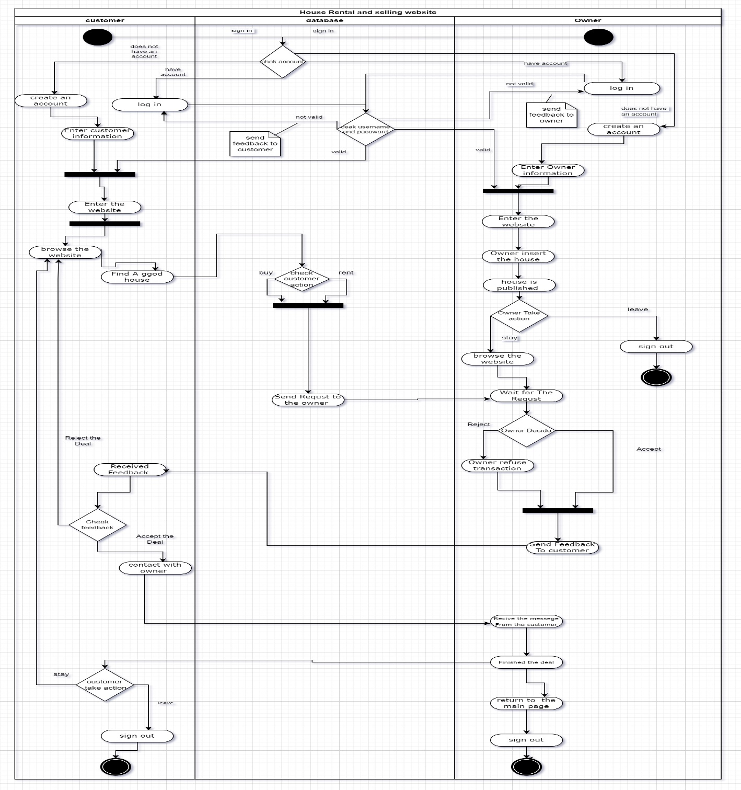

Figure (2): Activity Diagram

An Activity diagram is splatted to three sections, customer and database and owner, in general the diagram has a start and end point, and between of those two points, there is around sixteen actions, and Seven conditions.

Those are sub-Activity diagram for two compacted Actions, where show the flow of those Actions from the start to the end.

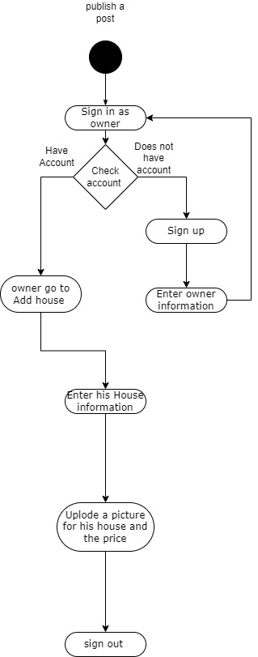

Publish Post Activity Diagram.

Figure (3): Activity Diagram

Figure (3): It shows a sub-Activity diagram for real estate website firstly the owner sign in to the website then the system check if he has an invalid sign in or not , if not the system shall ask him to reenter his information , if he has an account he goes to add a house part in his profile and add his house information then he posted it on the website .

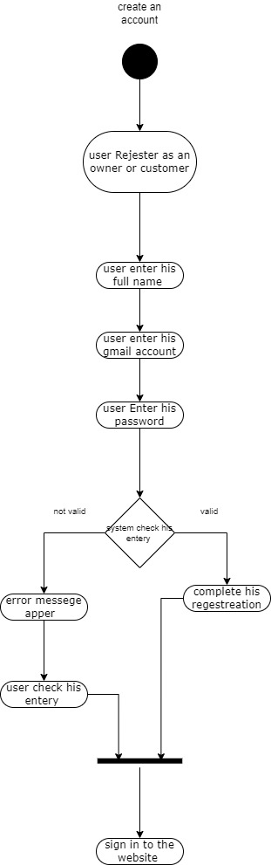

Create an account Activity Diagram.

Figure (4): Activity Diagram

Figure (4): It shows a sub-Activity diagram for real estate website firstly the user register as an owner or customer , then he enters his full name for create new account, then his Gmail, password the website checks of the validation of his entry whether its right or wrong.

**6.0 Design Phase**

**6.1 Architecture Design (ContextApplication Diagram)**

The context diagram is used to establish the context and boundaries of the system to be modelled: which things are inside and outside of the system being modelled, and what is the relationship of the system with these external entities. [3]

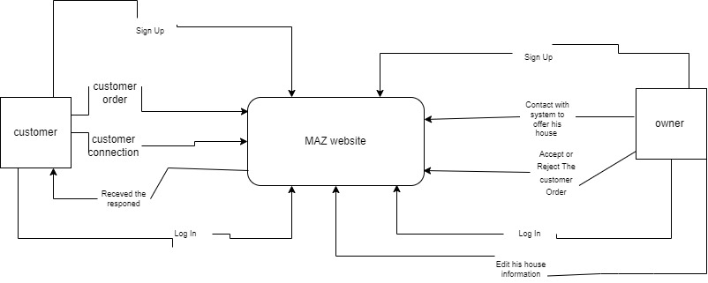

Figure (5): Context Diagram

It’s a zero level of data flow diagram we call it in system analysis and design context diagram its contains one process which it is the name of the system and the external entity (the one who will react with this system).

**6.2 Data Architecture Design (ER_Diagram):**

ER diagrams are used to model and design relational databases, in terms of logic and business rules (in a logical data model) and in terms of the specific technology to be implemented (in a physical data model.) [4]

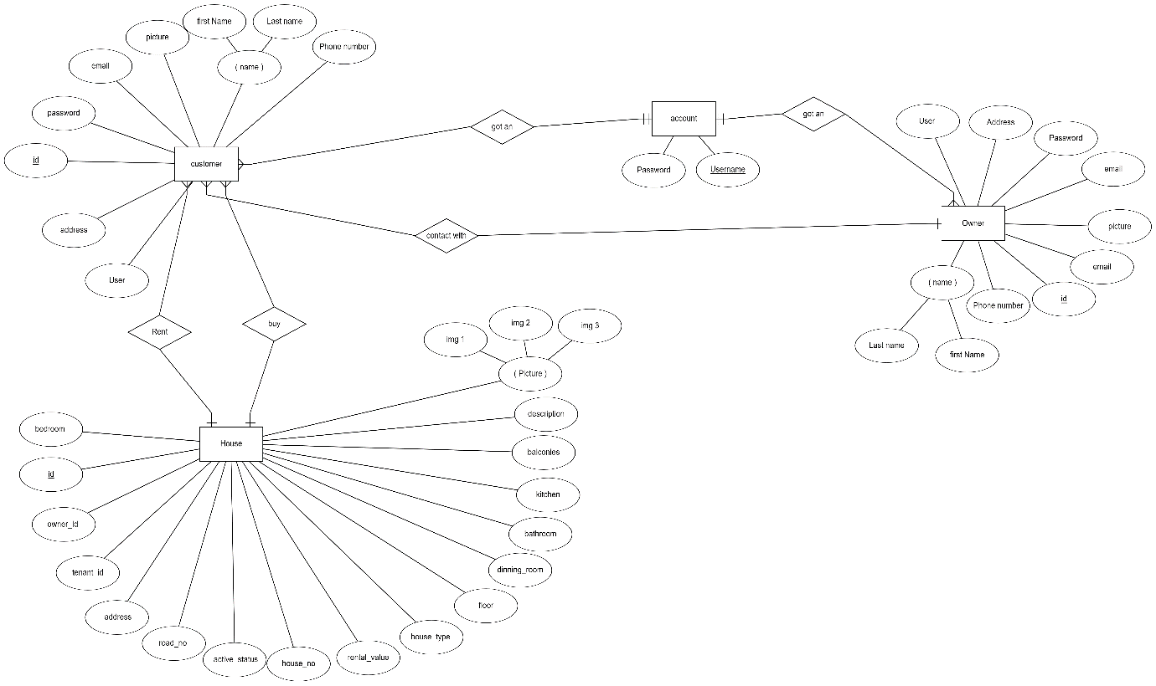

Figure (6):ER_Daigram

Figure (6): contains Four entities and 5 relationships, between all of the entity’s there are a relation that's bind each entity with another one, there are some entity that have many to one relation, for example one customer can buy or rent many houses.

**6.3 [Scheme diagrams / Database Logical Design]:**

A relational schema is a set of relational tables and associated items that are related to one another. All of the base tables, views, indexes, domains, user roles, stored modules, and other items that a user creates to fulfill the data needs of a particular enterprise or set of applications belong to one schema. [5]

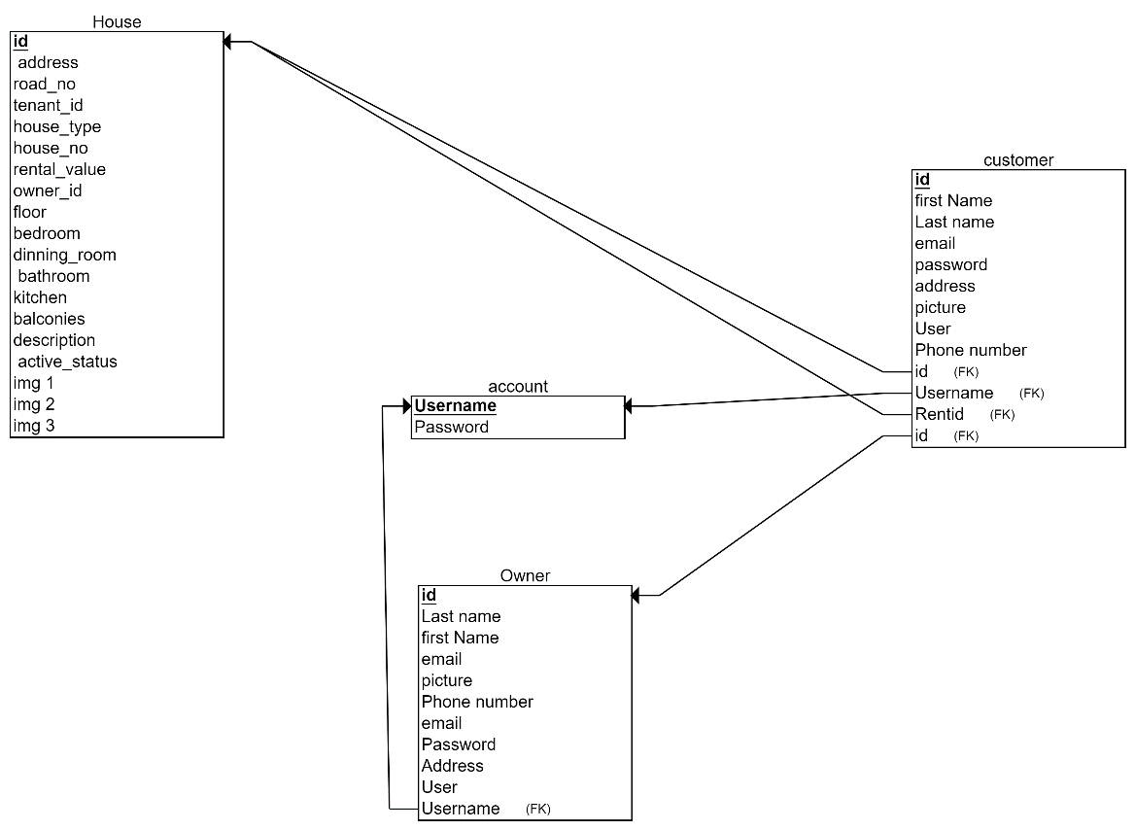

Figure (7):DatabaseLogicalDesign (Scheme diagrams)

This is figure for a relational schema that describe the ER_Diagram in tables, each table has his own attribute such as the owner have his first and last name each table has a relation with each other by using primary and foreign keys such as id attribute in house table this is the primary key, and id in customer table is the foreign key, that how the relation been created.

**References:**

[1]

<https://en.wikipedia.org/wiki/Use_case_diagram#:~:text=A%20use%20case%20diagram%20is,by%20either%20circles%20or%20ellipses>.

[2]

<https://www.smartdraw.com/activity-diagram/#:~:text=An%20activity%20diagram%20visually%20presents,can%20be%20sequential%20and%20concurrent>.

[3]

<https://www.cs.uct.ac.za/mit_notes/software/htmls/ch06s06.html>

[4]

<https://www.lucidchart.com/pages/er-diagrams>

[5]

<https://www.sciencedirect.com/topics/computer-science/relational-schema>